**CS691 - Computer Science, Spring 2021**

**Project Initiation Document**

Project: UnitedTune

Project Manager: John Brilhart

Start Date: 2/2/2021

Completion Date:

Table of Contents

Document Purpose **4**

Background to the Proposed Work **4**

Vision **5**

Project Objectives **5**

Project Scope **5**

Business Case **6**

Assumptions **9**

Constraints **10**

Risk Management Strategy **10**

Deliverables **11**

Stakeholders **12**

Project Team **13**

RACI Table **14**

Project Plan **15**

Project Controls **15**

Communication Plan **16**

Document Details

|  |  |  |  |
| --- | --- | --- | --- |
| Version | Modifications | Author | Date |
| 1.0 | Initial PID Document | John Brilhart | 2/7/2021 |
| 2.0 | Updated PID Document | John Brilhart | 2/15/2021 |
|  |  |  |  |
|  |  |  |  |

Approvals

This document requires the following approvals:

|  |  |  |  |  |
| --- | --- | --- | --- | --- |
| Name | Role | Signature | Date | Version |
| Prof. Yuri Chernak | Course Instructor |  |  |  |
| John Brilhart | Project Manager |  | 2/8/2021 | 1.0 |
|  |  |  |  |  |
|  |  |  |  |  |
|  |  |  |  |  |
|  |  |  |  |  |

Distribution

This document has been distributed to:

|  |  |  |  |
| --- | --- | --- | --- |
| Name | Role | Date of Issue | Version |
| John Brilhart | Project Manager | 2/8/2021 | 1.0 |
| Jay Patel | Product Owner | 2/8/2021 | 1.0 |
| Yashwanth Varre, Ge Ou | Lead Business Analyst | 2/8/2021 | 1.0 |
| Lead Developer | Hetali Chavda | 2/8/2021 | 1.0 |
| DBA | Revati Deshmukh | 2/8/2021 | 1.0 |
| QA Analyst | Suraj Suwal | 2/8/2021 | 1.0 |
| Tester | Soyeon Ju | 2/8/2021 | 1.0 |

# Document Purpose

The purpose of this document (Project Initiation Document-PID) is to define a UnitedTune web application project. It will introduce the business case involved with this project and identify various aspects of the project. This will be done assessing objectives, scopes, tasks, risks, costs, roles and responsibilities of the team and their communication plan, and plan associated with the project. Major areas that will be covered are:

* Project objective, specific outcome that will be achieved
* Expected benefits, cost and benefit analysis and risks analysis associated with UnitedTune application
* Roles and responsibilities of project manager, team, and stakeholders
* Timelines, assignments and tasks, resources, and management stages

Overall, this document serves as a guideline for the project’s progress and success by laying out objectives and justification, planning, and organization of the project.

# Background to the Proposed Work

When you look back on all of the important events in your life like proms, weddings, parties there is something that always stands out, the music. An event is incomplete without music. Sometimes, it is the most important part. Sometimes, the music needs to be perfect before you can plan anything else.

Sometimes It is hard for people to find musicians to make the best music for their events. Our service, UnitedTunes, would allow musicians to advertise their services like recording, performances, concert bookings and more on a platform that is built specifically for musicians and their customer bases. Customers can easily search for their desired schedules, or even negotiate prices. This service could also eventually expand to rental venues or equipment.

There are some applications that functionalize like this. Thumbtack is one of many popular apps that help customers look for local experts, but when it comes to musicians, the majority of them focus on lessons or tutoring. On most apps, customers have to rely on descriptions because there aren’t any videos to show the customer what they are offering. Upwork and Fiverr also connect experts or freelances to customers. Upwork has a relatively high proportion of high-end software and professional freelancers, while Fiverr has a high proportion of small-scale, amateur freelancers. The main difference between those apps and our website is that our platform is only for musicians and music lovers.

Musicians no longer need to worry about finding customers or promoting their music. Now, people who need to hire musicians can search through a live database of musicians who are currently freelancing in their area.

# Vision

At UnitedTune, our entire team is committed to helping you celebrate all of life's special moments—no matter how big or small. From booking a musician, our Account Specialists team is here to assist you at every level of the process.

We are committed to finding the best musician serving your event’s vision and budget. And when you hook with the perfect one—book with us, and our Guarantee we'll cover you.

We believe that your event is our reputation, and making your event dreams come true is our top priority. We're not satisfied until you're thrilled - that is our promise to you.

# Project Objectives

* Develop a secure, convenient, and user-friendly web-based platform for music-band rental services available to consumers.
* Connect customers and musicians directly to rent music related services.
* Transform the manual process of renting a band/musician to an online, computerized, and 24x7 available system.

# Project Scope

UnitedTune is an online rental web application aimed at taking band/musician rental services to customers' fingertips. The web application acts as an open platform where customers and musicians can come together, musicians can advertise their services, and customers can select services based on their interests. The web application does not offer any other event management services; it only provides band/musician rental services to make their event more memorable.

In the initial stage, the application will provide services to small regions and will expand further in the long run. The web application modules will include customers and musicians registration, booking system, payment operations, reservation processing, rating and feedback, and the administration panel for overall management. The application will provide a high level of security and integrity of the system's data and will always be available for access. The GUI of the web application will design in such a way that it will be easy to understand for end-users.

Overall, UnitedTune is a platform that will motivate musicians to offer their services to customers. Customers will be able to see these services and their availability and make reservations from the web application with just a few clicks.

# Business Case

UnitedTune provides a platform for musicians to advertise their services. It gives an opportunity for artists to show their skills and motivate them to create good music by offering them extra earnings. On the other side, it serves as a great research source for the customers to hire musicians of their interest in life events like weddings, birthdays, graduation, etc. Usually, it is very hard to find a good resource on such artists and most people have no idea on where to start from if they want to hire musicians. UnitedTune solves that issue by offering plenty of information about services, types of music, areas of operation, and costs all at one place. Customers will be able to make a choice suitable for their event by listening to the compositions, reading the reviews of the artists they would like to hire and also by comparing prices. This will save their time and money if they will be hiring any event managers. Further, event managers will also be able to utilize the same services. Overall, UnitedTune creates a bridge that will be able to bring the artistic community closer to our day to day lives.

|  |  |
| --- | --- |
| **Application Name** | UnitedTune |
| **Type of business model** | Brokerage/Platform/Advertising  UnitedTune would connect customers to musicians selling their services(entertainment, recordings etc.) There would be a percentage based fee for each transaction on the seller’s end. |
| **Target audience of external users**  **(Customer Segments)** | **For whom are we creating value?**  **Who are our most important customers?**  Musicians(looking to sell their services)  Customers(looking to hire musicians) |
| **Groups of internal stakeholders, business users** | **Do we need a product development group?**  Yes we need a product development group to develop the platform.  **Do we need a sales group?**  Sales will be promoted by the client through use of the platform.  **Do we need a finance group (accounts payable, receivable)?**  We will use a finance group to deal with all transactions between client and customers.  **Do we need a customer support team?**  The customer support team will assist with any problems with transactions between client and customer in additions to any issue with accessibility of the platform.  **Do we need an advertising management group?**  The advertising management group will develop and distribute advertisements to help increase exposure of the platform. |
| **Value propositions** | **What value do we deliver to the customer?**  “UnitedTune” is a website that lets users research, hire, rate, and review musicians for free. You'll find a variety of musicians here.  **Which one of our customer’s problems are we helping to solve?**  We are solving three types of problems:   * Reachability to the locals * Band Popularity * Time management   **Which customer needs are we satisfying?**  We offer a variety of musicians according to the customer's taste of music, availability, budget, etc. |
| **Key resources** | **What Key Resources do our Value Propositions require?**  UnitedTune’s main resources are its engineering employees, who maintain and update its platform for customers.  **Our Distribution Channels?**  Our main channel is the website. The company promotes its offering through its social media pages.  **Customer Relationships?**  Our customer relationship is primarily of a self-service nature. Customers utilize the service through its website.  The site provides several self-help resources, including cost estimates, tips for musicians, and answers to frequently asked questions.  **Revenue Streams?**  “UnitedTune” has two revenue streams: the fees it charges per transaction on the seller side and advertisements. |
| **How the system is used** | **What are the main business use scenarios?**  UnitedTune would connect customers to musicians selling their services (entertainment, recording, ect.) There would be a percentage based fee for each transaction on the seller’s end. Users can research, hire, rate, and review musicians for free and also find a variety of musicians here according to the requirements like budget and availability. (For example, I arrange my birthday-party and I need a Dj for my party. So, I can go on the “UnitedTune” website and book a Dj by reading reviews.) |
| **Revenue generation, Revenue streams** | * Advertisements * Service charges |
| **Key Partners/Suppliers**  **(Stakeholders)** |  |
| **Expected Benefits** | 1. Booking tours are time-consuming and involve juggling dates and other details. Having an online platform for such things will provide more convenience and ease. 2. This platform will be ideal for customers as it will serve as a single platform for all music services. 3. Operate around the clock for seamless customer experience. 4. There will be no dependency on any middle man. A customer can reach out to a musician/band directly. 5. Customers can pick the best musician/band based on reviews/feedback. 6. Musician doesn't need to spend their resources (time + money) on marketing. 7. Customers can compare the cost and type of services provided by the musician/band. |
| **Known Prototypes** | Reference some known portals on the Internet that are similar to your business case. You will use these prototypes for developing business, user requirements.   1. Fiverr.com (<https://www.fiverr.com/categories/music-audio/session-musicians?source=category_tree,><https://www.thumbtack.com/k/solo-musician-for-hire/near-me/>) 2. Thumbtack (<https://www.thumbtack.com/k/solo-musician-for-hire/near-me/>) |

# Assumptions

This section will include assumptions made before the requirements specifications have been documented. It may look something like this:

|  |  |  |  |
| --- | --- | --- | --- |
| Assumption | Validated by | Status | Comments |
| Participation Time (8hr/week) | All Members | Confirmed | An adequate staff asset is accessible for all parts of the venture to meet the announced time scalers. |
| Project Fund | Stakeholders | Not Confirmed | The sufficient subsidizing is made accessible. |
| Code coverage | Technical Team | Confirmed | We do proof-reading by writing unit tests, achieving 100% code coverage. |
| Support Service | All Members | Confirmed | There are dedicated teams assigned to serve each department. |
| Secure payment | Financial Team | Not Confirmed | N/A |
| Hardware/Software requirement | All members | Confirmed | Sufficient product/equipment and archive arrangements needed to build up the project are available. |

# Constraints

This section will outline the things needed to be taken into consideration during the delivery of the project; this may include, but is not limited to:

1. **Delegation:** Our team is very small, and we have limited time. To compensate when a team member is responsible for a deliverable they will delegate duties among the other team members to ensure timely completion on all task
2. **Compatibility:** Our main deliverable will be a web application, thus it is imperative that our website functions well in various web browsers.
3. **Mobile Sites vs Responsive site:** Since many people access the internet on their mobile devices we must make sure our website is compatible with mobile web browsers.
4. **Deadlines:** Deadlines must be followed strictly, the project manager will be informed of any delays to allow the team to compensate and remain on schedule.

# 

# Risk Management Strategy

|  |  |  |  |
| --- | --- | --- | --- |
| Risk | Probability | Impact | Mitigation Method |
| Varying experience among team members will lead to roadblocks and slow downs | Medium | Medium | Constant communication among team members regardless of assigned roles will help tackle any problems with deliverables before the deadline |
| Schedule difficulties will cause conflicts in completing deliverables and attending meetings | High | High | Utilizing Slack to catch up team members who are not able to attend Zoom meetings, and keeping weekly minutes to ensure all team members all have the same information |
| The limited amount of time to complete deliverables will lead to decreased quality and increased errors | Low | Medium | The team will utilize peer reviews to ensure all deliverables meet the appropriate standards |
| Loss of software or other deliverables due to data corruption or hardware failure | Low | High | All deliverables and source code will be backed up on the teams shared google drive folder and/or a GitHub repository |
| A security failure will lead to loss of cloud backups and potentially personal information. | Low | High | Team members will not share any folders or links to cloud storage to anyone outside the team except when requested by the Professor |

Overall most of the risks above can be mitigated by proper communication among the team by utilizing weekly team meetings and Slack. Due to our small team size it is imperative that team members assist each other when needed, even if that task is outside their assigned team role. The advantage of this however is that each team member will gain experience in many different project roles which will benefit them in their future endeavors.

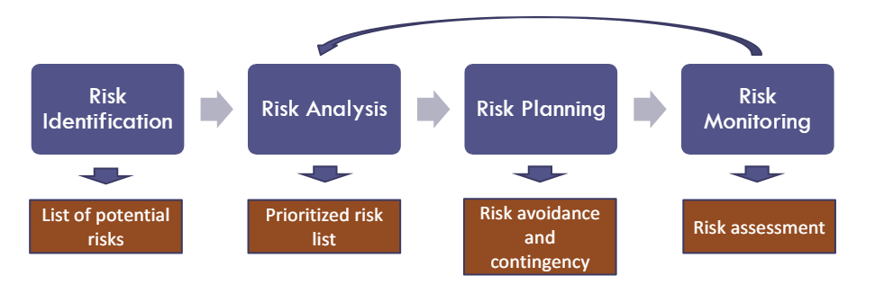

# Deliverables

This section should include the main deliverables and outcomes the project is expected to achieve. It may be presented in the following format (see the project delivery schedule on Blackboard):

|  |  |  |
| --- | --- | --- |
| No | Artifact Name | Responsible Party |
| 1 | Project Plan | PM |
| 2 | PID document | PM |
| 3 | BRM Diagram; User Roles | Product Owner |
| 4 | Context Diagram; System Interface Table | Lead BA |
| 5 | Architecture Diagrams (Logical, Process views) | Lead Dev/DBA |
| 6 | Business Requirements | Product Owner |
| 7 | RCT (includes func. decomp., suppl. reqs) | Lead BA |
| 8 | Use-Case Diagrams (UML) | Lead BA |
| 9 | Activity Diagram (UML) | Lead BA |
| 10 | Data-flow Diagrams (logical, physical) | Lead BA |
| 11 | Functional Requirements (user stories) | Lead BA |
| 12 | Class Diagrams | Lead Dev |
| 13 | Sequence Diagrams | Lead Dev |
| 14 | ER Diagrams (conceptual, logical) | DBA |
| 15 | Table Specifications (Data Dictionary) | DBA |
| 16 | Source Code sample (part of Demo) + GitHub repository slides (images) | Lead Dev |
| 17 | Test Plan document | Lead QA |
| 18 | Presentation, Application Demo | ALL |

# Stakeholders

This section will include a list of all known stakeholders and their interests in the project. It may be presented in the following format:

|  |  |
| --- | --- |
| Internal Stakeholders | Interest |
| Sales Group | To handle sales promoted by the client through use of the platform |
| Finance Group | To deal with all transactions between client and customers. |
| Advertising groups | To manage advertisements on the website |
| Customer Support Group | The customer support team will assist with any problems with transactions between client and customer in additions to any issue with accessibility of the platform |
| External Stakeholders | **Interest** |
| Musicians | Users who want to rent/sell their services |
| Customers | Users who intend to buy the services provided by the artists on website |
| Social media partners | To manage advertisement on the website and also promote our website on various social media platforms |
| Event Management agencies | If needed to host musical concerts |
| Law Firm | To generate a service agreement and registering trademarks and copyrights with government offices, registering with private (non-government) PRO and other collective legal formalities when needed |

# 

# Project Team

Team Members & Assigned Roles:

➢ Project Manager -John Brilhart

➢ Product Owner -Jay Patel

➢ Lead Developer –Hetail Chavda

➢ Business Analyst –Yashwanth Varre, Ge Ou

➢ DBA –Revati Deshmukh

➢ QA Lead –Suraj Suwal

➢ Tester -Soyeon Ju

# RACI Table

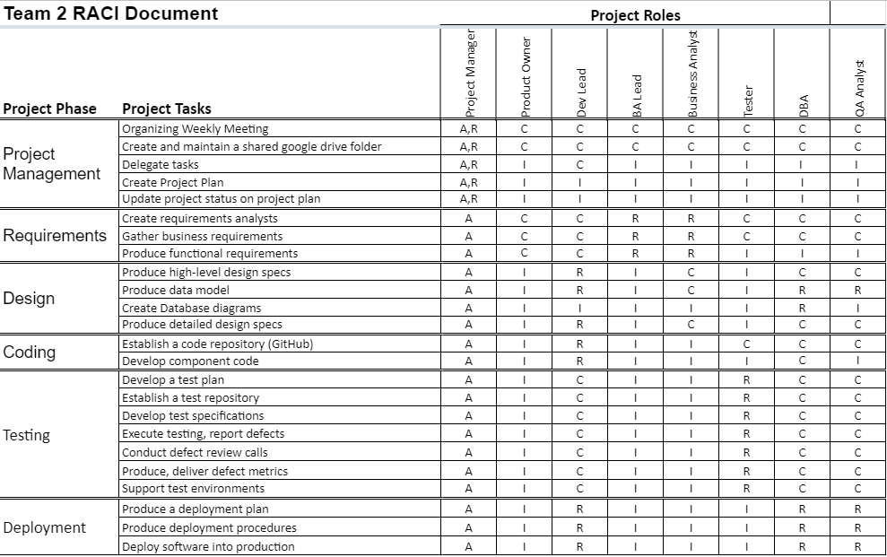

# Project Plan

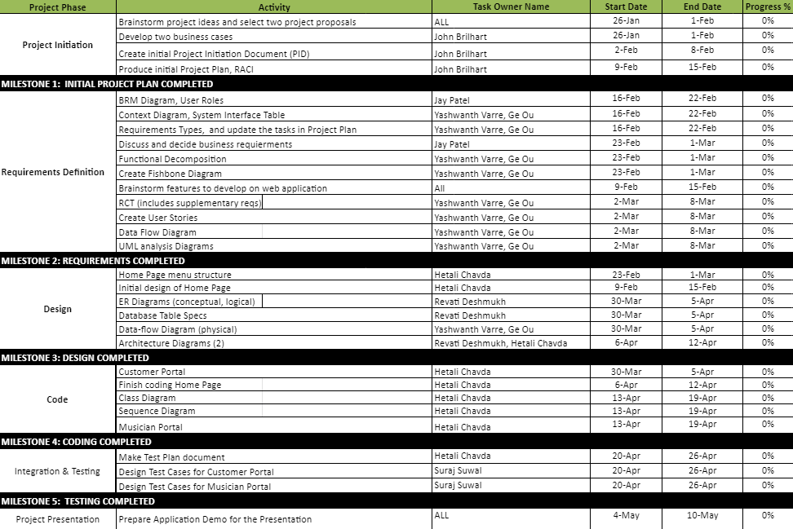

# Project Controls

* Project manager is responsible for organizing weekly team meetings. A team meeting is conducted every monday just after the class. According to the goals and deliverables, a second meeting might be scheduled.
* All the team members are expected to present for the meeting. Work is distributed by the project manager among team members equally.
* Weekly minutes are maintained by the project manager and are reported to the professor.
* Project meetings are held via Zoom, and regular contact is maintained by the team using slack.
* Google drive is used for official documentation. Documentation is updated frequently in the drive
* A github repository is used for source code and it is frequently updated if the changes are made to the source code.

# Communication Plan

This section will include how stakeholders will be communicated with during the project and how frequently. This should include a note on where to find the Communications Plan if you have one.

|  |  |  |  |
| --- | --- | --- | --- |
| Stakeholder | Frequency | Type | Purpose |
| Project Manager | Daily | Zoom, Slack, Phone | To discuss the project estimates ,requirements and weekly goals. Resolving any issues related to communication among the team. |
| Professor | Meeting and deliverables drafts | Email, Slack | Approval of project Implementation. Getting feedback regarding defects and suggested solutions for them. |
| Project Team | Daily | Slack, Zoom | To discuss the working progress of goals and deliverables |
| End Users | Daily | Email, Zoom for Business and testing sessions | To get feedback from the end users and to maintain transparency during online testing sessions. |